I. Characters

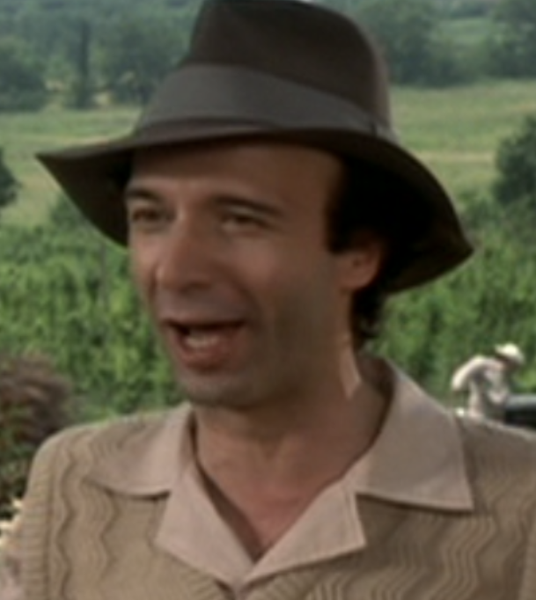 | 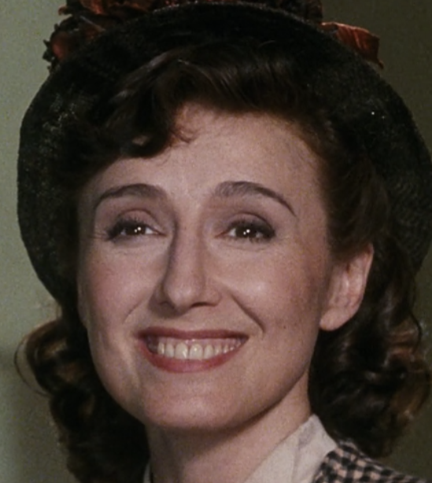 | 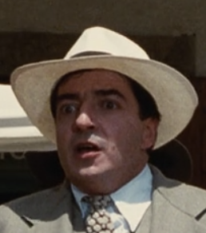 | 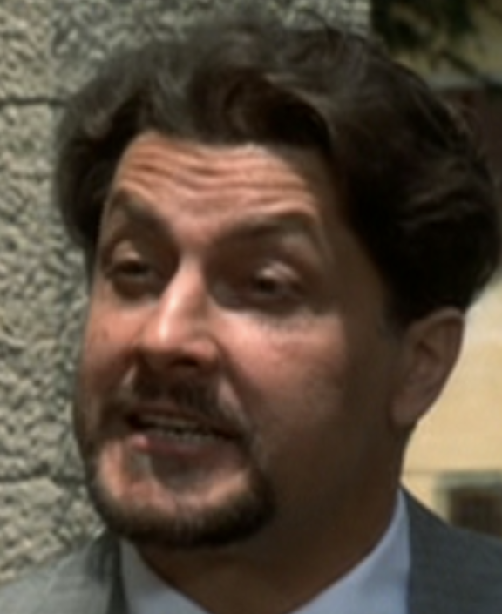 | 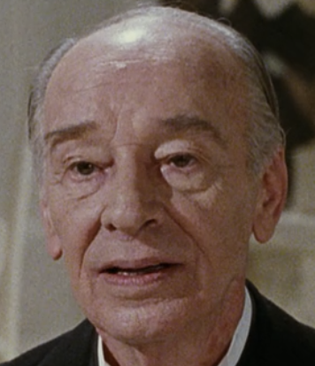
Guido Orefice | Dora | Ferrucio | Rodolfo | Eliseo Orefice
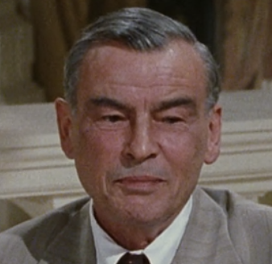 | 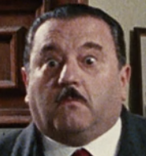 | 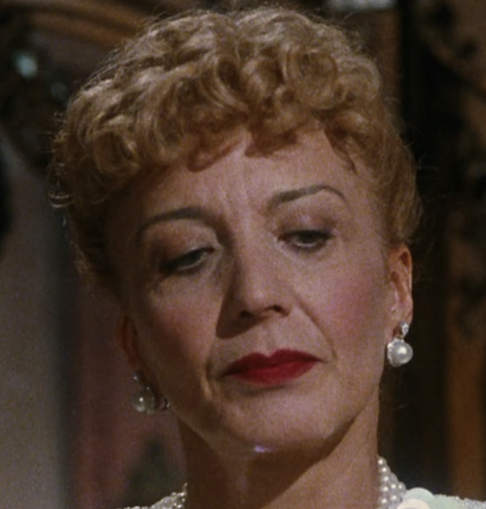 | 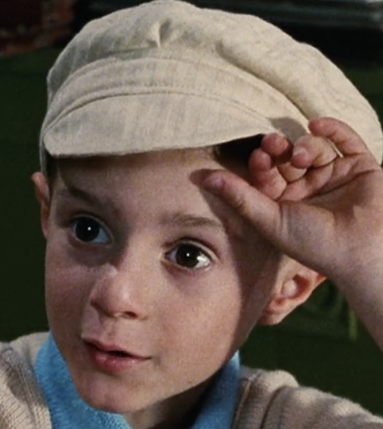 | 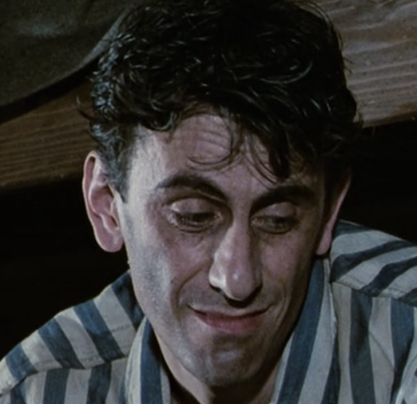
Doctor Lessing | Inspector from Rome | Dora’s Mother | Giosue | Bartolomeo

II. Film Viewing

1. What title does Guido come up with for himself when he meets Eleonora? (Notice how this connects to the previous scene.)

2. What title does Guido give to Dora when he meets her for the first time?

3. What does Uncle Leo (short for Eliseo) say is the most powerful cry?

4. What business does Guido hope to open up in this new city?

5. In the meantime, what job does Guido take on?

6. Ferrucio explains to Guido: “Schopenhauer says that with will power, you can do anything. I am what I want to be.” Ferrucio uses Schopenhaur’s ideas to help him do what in this scene?

7. After Guido surprises Dora again on the streets, do we get the impression she likes him? Why?

8. What answer does Guido have for Doctor Lessing’s riddle, “The more there is of it, the more difficulty you have seeing it”?

9. What is the principal expecting the Inspector from Rome to speak about?

10. Does Guido believe that the Italian race is superior? How does he mock this belief during his speech?

III. Reflection.

Day One. A film director, like a writer, introduces the audience to key characters, relationships, and conflicts while establishing a clear mood in the exposition.

What relationship does the director Roberto Benigni develop most clearly in the film’s exposition?

What do we understand about this relationship at this point in the film?

Identify one specific scene that is the most revealing about this relationship. What did you see, hear, and notice in this scene that helped the audience understand this relationship clearly?

